**Arrays**

Arrays is a composite data structure used to store collection or list of primitive | special data in some specific order [1st, 2nd, 3rd] in a single identifier (memory location).

Array is a reference data type with a huge number of preserved memory locations with **undefined** value (default value) that means you can add any number of elements.

JavaScript arrays are index zero-based, meaning the first element index is 0, the second is 1, third is 2… etc. this enables pointer memory location to reach a specific data inside this array by arrayName[index-number].

Index-number of elements inside array is:

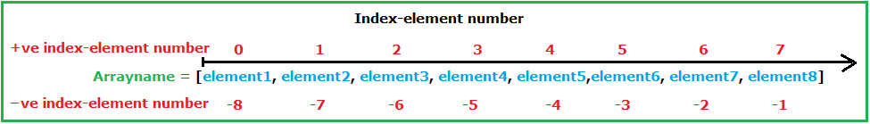

There are **2** types of arrays:

1. **Constructor array**
2. **Literal array**

**Constructor array ():**

The array constructor can be created by using ‘**new**’ and **Array ()** keyword.

**Note:** Constructor array is bad practice array.

**Syntaxes:**

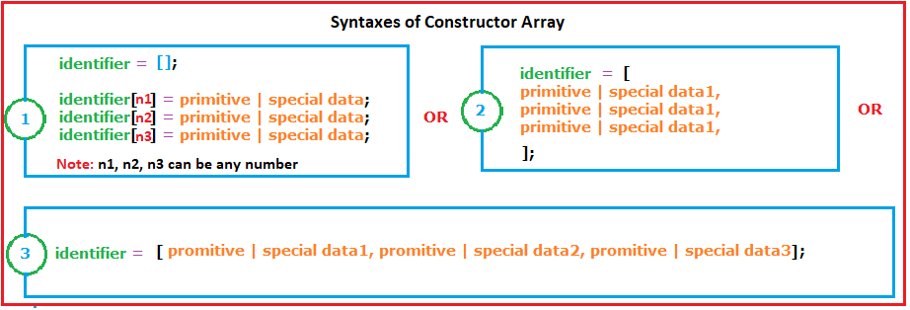

**Examples:**

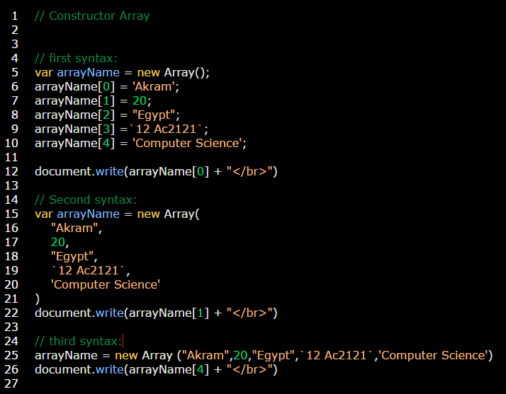

**Literal array []:**

The array constructor can be created by using **[]** without **new** keyword.

**Note:** Constructor array is bad practice array.

**Note:** Literal array is a good practice array.

**Syntaxes:**

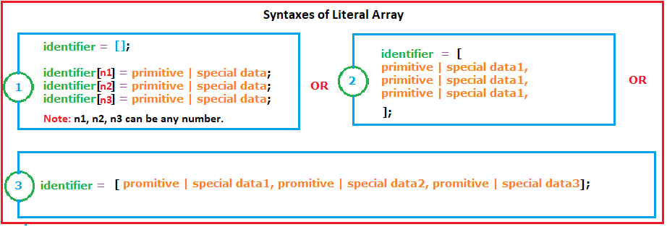

**Examples:**

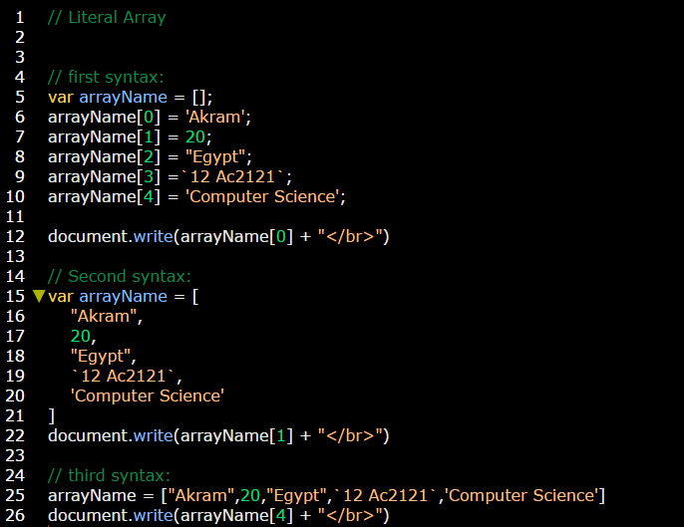

Array is a **mutable** data type that means you can add and set specific element inside this array.

**Example:**

